Chapter 15, Solution 5.

- 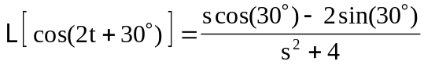
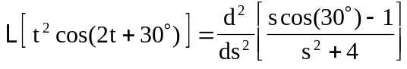
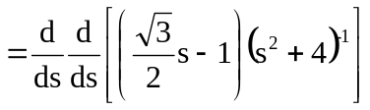
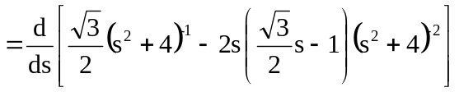
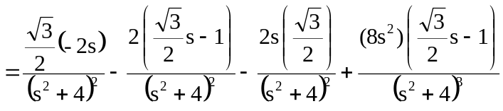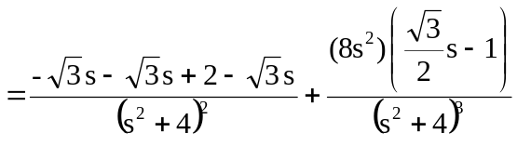
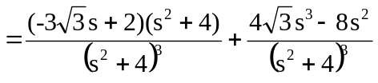
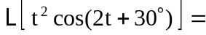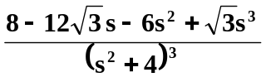

- 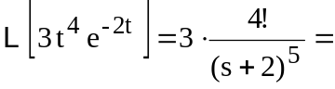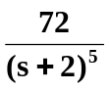

- 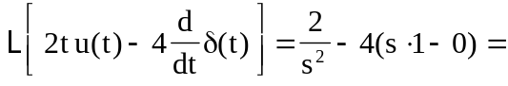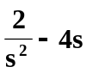

- 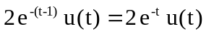
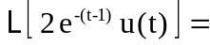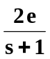

- Using the scaling property,
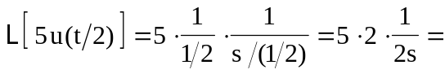

- 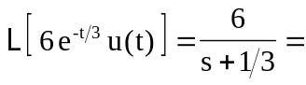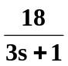

- Let 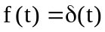. Then, 
